Made with switches:
AND
https://www.tinkercad.com/things/9iaEeSCWrs1-and-switches?sharecode=8rFlDFFoadHLOuJIRwZApYKpUpOkz-oRofonrbP5ym8
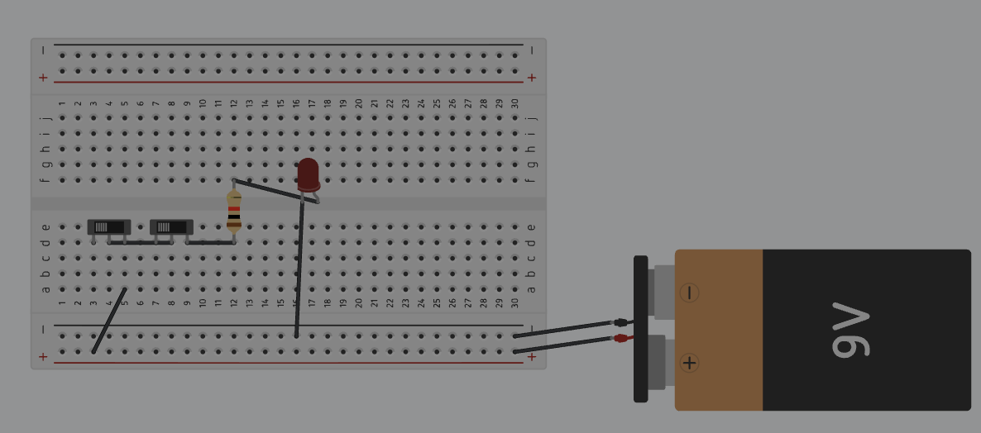
OR
https://www.tinkercad.com/things/9cA7SXvJq36-or-switches?sharecode=Y6cnYClfg7NAjSAZqusqln-at1M1o_MpmFxN9YzDpkI
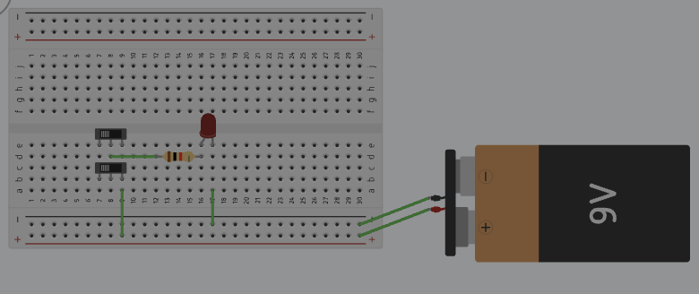

NOT
https://www.tinkercad.com/things/jaJOOUzVMJt-not-switches?sharecode=lmIW9f3fnfiNtXaef4ZxGLTbNWmqm129OSvTtuvGu0w
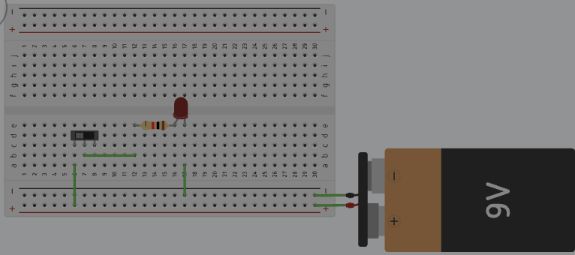
XOR
https://www.tinkercad.com/things/2qA7NcWIP5O-xor-switches?sharecode=iv1Na2Wtpd74aSwvCNJ33s1MfdTkLzEFPhRbiWiCHDc
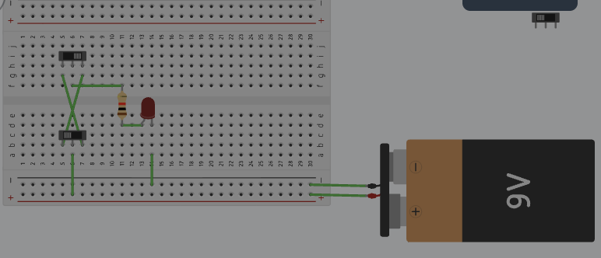

XNOR
https://www.tinkercad.com/things/bSSOOJsnu8I-xnor-switches?sharecode=2hX5qnqhTULs7yepK6iERsODgGmOYhXy1BDvKQUa3KQ
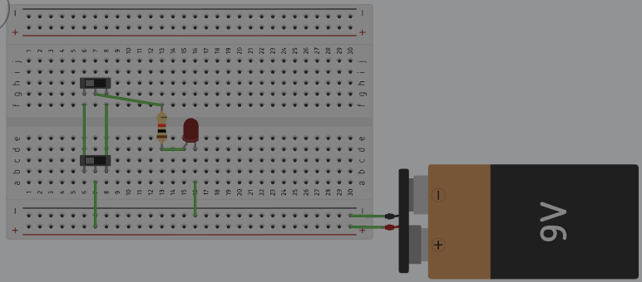
Traffic lights
https://www.tinkercad.com/things/goG9R5W2dlT-traffic-lights?sharecode=Gls97E6JeRL11zSBYeoMF2xAXqevAURvONPQ-R3aZSc
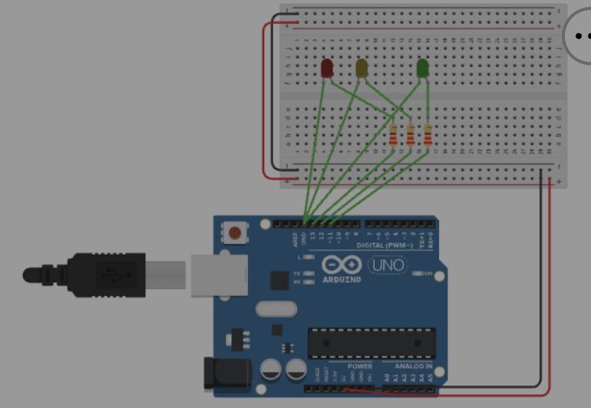

Ultrasound
https://www.tinkercad.com/things/9eR0xdHk6kO-ultrasound?sharecode=dww04XuUvNebyE2IWjloUZ7J4cmk8gtd2le_TTbxgSE
LDR
https://www.tinkercad.com/things/0Dcx18kpshs-ldr?sharecode=d7-AAojkZogrKd865UR22yMYKKMu1k7N0_dDTo2gl-c
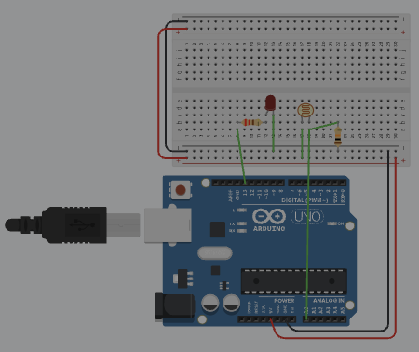

Security Ultrasonic with buzzer
https://www.tinkercad.com/things/iVrz6IqiD3s-security-ultrasonic-with-buzzer?sharecode=he7_9UObJx3lAf30XC6X73u3wRTwCchUaFDJX3YGPvY
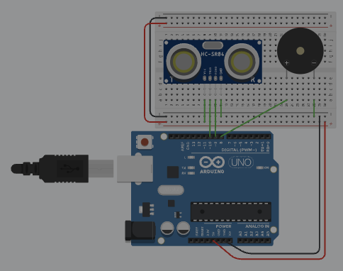
Made with diodes
OR
https://www.tinkercad.com/things/iEAXi0sV3Np-or-diodes?sharecode=KDPej3HYduq0w2ilXMM__KnzHCMoZIsbXas2QsIne20
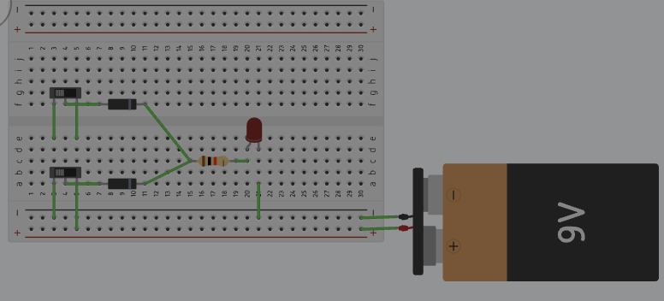

AND
https://www.tinkercad.com/things/aY9BfcekMYN-and-diodes?sharecode=GesrQSiaFcHgH3mmlarA2e-jIeWAkEx8N-6QVFsEqKk
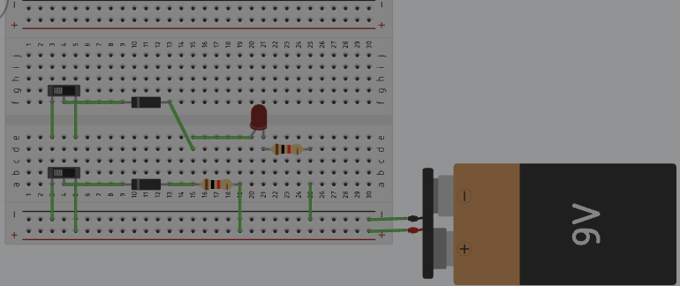
XNOR
https://www.tinkercad.com/things/5pwtHKWT7gW-exnor-diodes?sharecode=F9CGxSZcgo0UnzpNQ8N443aSgYZFPVUFmxAgjQgJa3U
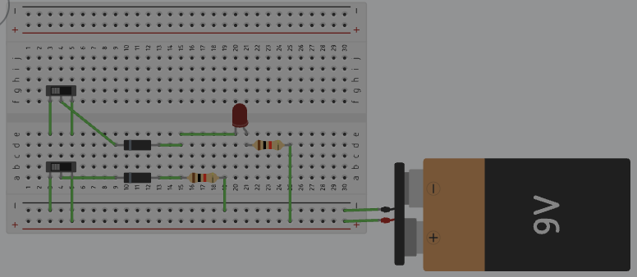

NOT
https://www.tinkercad.com/things/eIuSCyu6Hyk-not-diodes?sharecode=Mca1O_UwiPs2YP4QrKGCkQ2EBrXB5YioLlzHV53-XG8
